ARI2101

Fundamentals of Automated Planning

Assignment 2024/2025



Pawlu Spiteri

pawlu.spiteri.23@um.edu.mt

4105H

Matthew Farrugia

matthew.m.farrugia.23@um.edu.mt

Part 1:

Programming Language: Java 17.0.13

**State Implementation**

This state class encapsulates the board configuration, movement history, and heuristic information.



The board configuration is held in a one-dimensional integer array of length nine, with the integers ranging from 0 to 8, and 0 being the empty tile. To track the position of the empty tile an emptyTileIndex variable is maintained. This reduces constant looping through the board to find the empty tile, improving time to calculate possible moves and tile swapping.

Maintaining a reference to its parent state, null in the case of the initial state, enables retracing after a search concludes.

Maintaining move type, represented by a characters (1, u, r, or d), representing left, up, right, down respectively. This is used to represent the move done to reach the state from its parent state. This character is used during the plan validation step to validate a generated plan.

To support heuristic-based search algorithms, distance costs are maintained including cost to from initial state to state n (gCost), heuristic estimate from state n to goal state (hCost), and total estimated cost (fCost(), which is simply gCost + hCost).

By overriding equals and hashCode, the class ensures that comparisons and hash codes are computed based on the board configuration alone, ignoring differences in other attributes like parent reference or move done. This allows for states to be accurately identified and managed in data structures such as hash sets.

The state class also provides a children method to generate all valid successor states. Successors are generated based on the precondition: if the empty tile has an inbounds neighbour. For each valid neighbour a child state is created where the neighbouring tile and empty tile are swapped using the Swap helper function. The child state’s parent reference is set to the current state and the action performed to generate the child is recorded accordingly.



**Result Implementation**

//Runtime figures – unique states, duration

Duration of search is done within the search algorithm and does not include time taken to validate, generate and print out results.

Unique states visited is calculated by summating the number of the states in the closed hash set, and the number of states in the edge states data structure.

//Retrace path – moves, actions, boards

The retrace step traverses the path taken from the final state to the initial state, through parent references until parent is null. At each parent actions taken is incremented, the parent’s board is pushed onto a stack, and using stack’s first in last out order to reverse the plan. This correctly describes the plan as going from the initial state to the final state.

By the same logic moves are also pushed onto a stack but the last move is ignored, null.



Plan Validation Step - validity

After plan is in correct order, a plan validation step is executed to validate if a plan correctly reached the goal. This is done by peeking the initial board and simulating all the moves in order and if the board matches the goal board then the plan is marked as valid.



**Distance Functions Implementation**

The DistanceFunctions class contains the implementation of the manhattan distance and misplaced tiles functions.

Manhattan - Compute a lookup table for the destination tiles, mapping each tile value to its index. For every tile value in the start state, find its corresponding index in the destination state using the lookup table. Calculate the tile's 2D position by using the modulus operator to determine the x-coordinate and integer division to determine the y-coordinate for both the start and destination positions. Compute the absolute differences between the x and y coordinates, and sum these values to derive the total Manhattan distance.

Misplaced Tiles - Checks weather the tile values match at a specific index, if not increment cost.

Testing using Figure 2, gives expected heuristic values

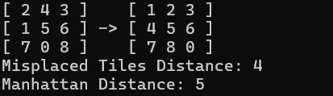

**Search Algorithms Implementation**

- In all implementations a hash set is maintained to store explored states since its lookup and add times are both constant.

- In all implementations except for enforced hill climb, a hash side is maintained alongside the queue or a variation of it to speed up lookup times from O(n) to O(1). This doubles the size needed to store enqueued states but since layers grow exponentially with depth and lookups happen multiple times per state dequeue, it is a trade-off needed to drastically improve search times.

- States having boards identical to the boards of other states are considered redundant. Maintaining hash sets that store both explored and unexplored states (In the case of EHC a hash set containing the unexplored is not maintained), helps to lookup generated children states before enqueuing or pushing to avoid going in circles.

- A search will run until either the goal state is found or the data structure storing the unexplored states is empty.

**Breadth First Search**

The breadth first (BFS) search will run until either the goal state is found or the queue storing the unexplored states is empty. This implementation employs a queue to store unexplored states. This ensures that layer $n$ is exhaustively explored while enqueuing layer $n+1$. Alongside the queue is a hash set used to speed up state lookups from O $(n)$ to O $(1)$. Since layers grow exponentially with depth and lookups happen multiple times per state dequeue, lookup speed is an important consideration.  
A hash set is maintained to store explored states since its lookup and add times are both constant.

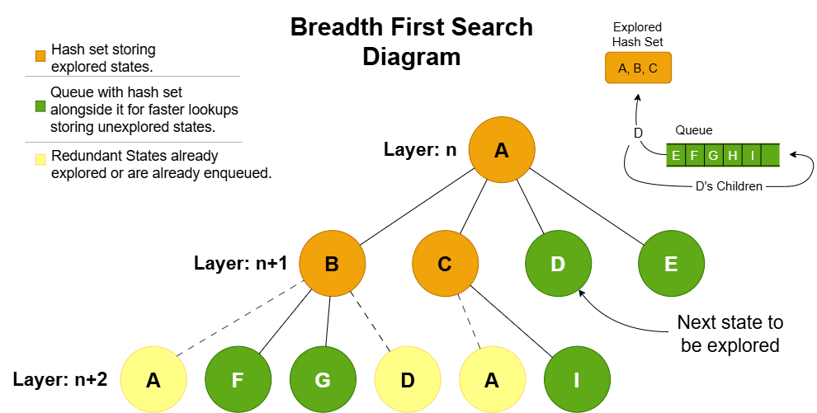States which have boards identical to the boards of other states are considered redundant. Maintaining hash sets that store both explored and unexplored states helps to lookup generated children states before enqueuing them to avoid going in circles. 



**Greedy Best First Search**

The greedy best first (GBFS) search will run until either the goal state is found or the queue storing the unexplored states is empty. This implementation employs a priority queue to store unexplored states. The priority queue enqueues according to the heuristic estimate to the goal state. It also maintains a hash set alongside the priority queue as in the previous search algorithm.

A hash set storing explored states is maintained as in the previous search algorithm.

Redundant states are handled by checking against the hash sets storing explored and unexplored states as in the previous search algorithm.

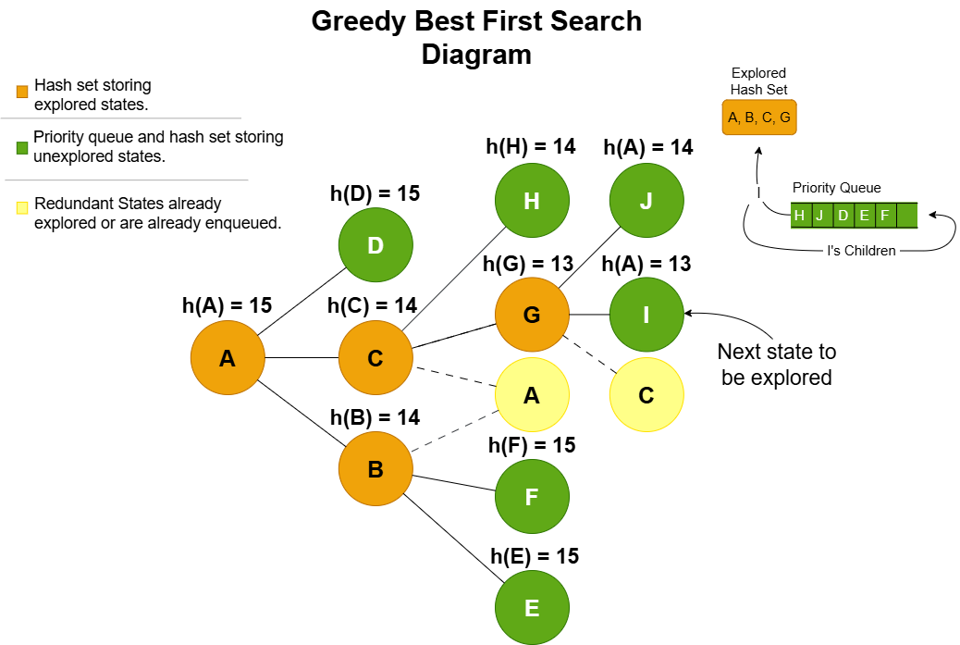

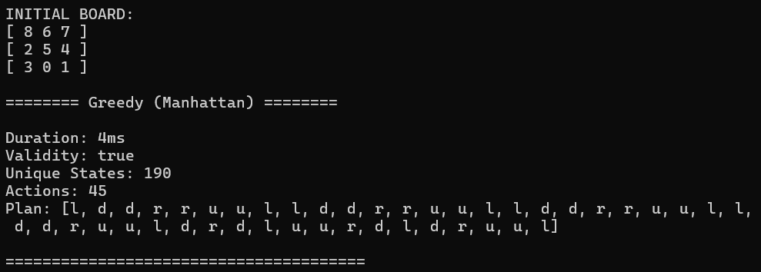**A* Search**

The A* search implementation employs a priority queue to store unexplored states. The priority queue enqueues according to total estimated cost, and then if two states have the same total estimated cost, they are checked against their heuristic estimate to the goal state. It also maintains a hash set alongside the priority queue as in the previous search algorithms.

Since moves are limited to cardinal directions the distance between a state and any of its children is always 1. Therefore a child’s gCost is its parent’s gCost incremented by 1.

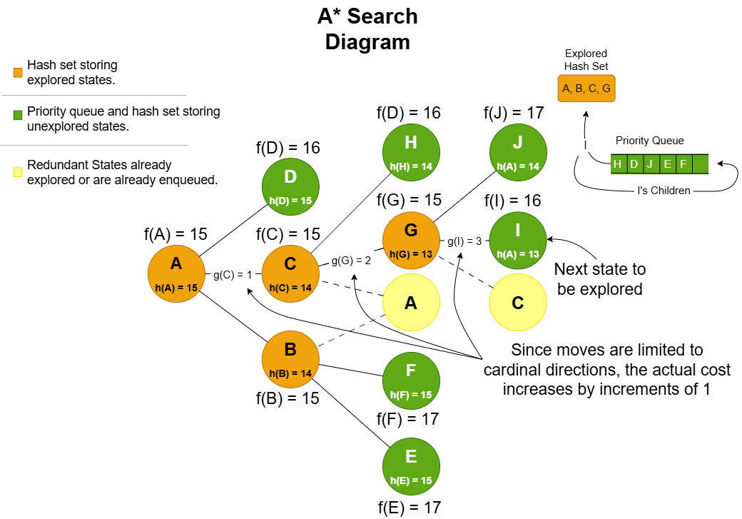



**Enforced Hill Climb Search**

The enforced hill climb (EHC) search implementation without backtracking results in immediate termination. Termination occurs when a state has no immediate improvements and as such will return an incomplete plan. Since local minima are extremely common in the search space this often results in plans of length zero or one. Therefore backtracking was implemented to return previous states and explore alternative branches. Backtracking was implemented using a stack, representing the search’s history. When a child is found to have a better heuristic estimate it is immediately pushed onto the stack and explored. In the case then where no improvements are found all child states are pushed onto the stack allowing for rerouting. Considering child states as equal to the best state helps direct the search and converge faster.

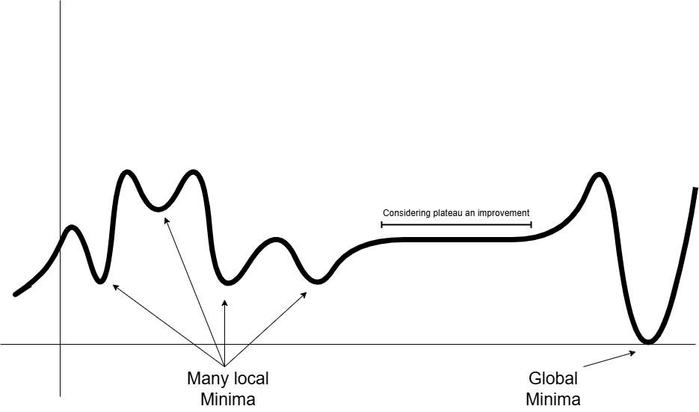

**Menu**

Search options include the four search algorithms and an option to perform all search algorithms. For this option the algorithms requiring a distance function are for both distance functions. It also displays a summery and writes the summery to a csv file for further graph representation using a python script.

Distance function option is available for options [2], [3], and [4].

The print board option is available for each search algorithm except for option [5].

The initial state option offers three default states; Test initial state 1, Test initial state 2 and an unsolvable state, and an option to input a custom board configuration.

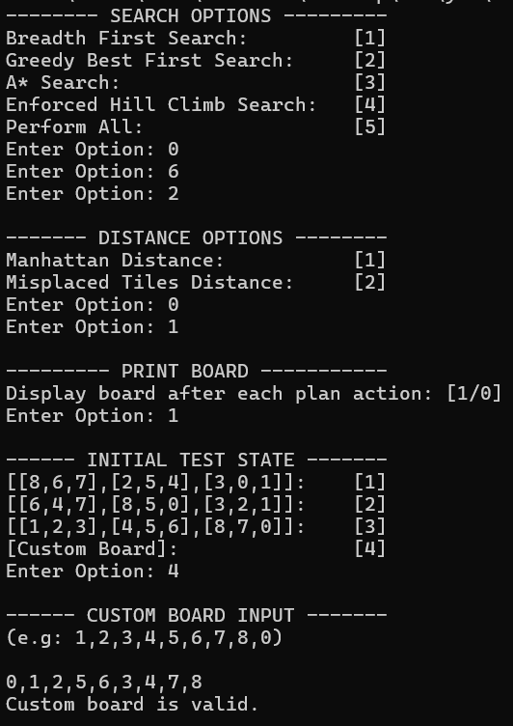

**Plan Output**

An example output including the required figures and information with the optional board at each step. The printing of boards was truncated.

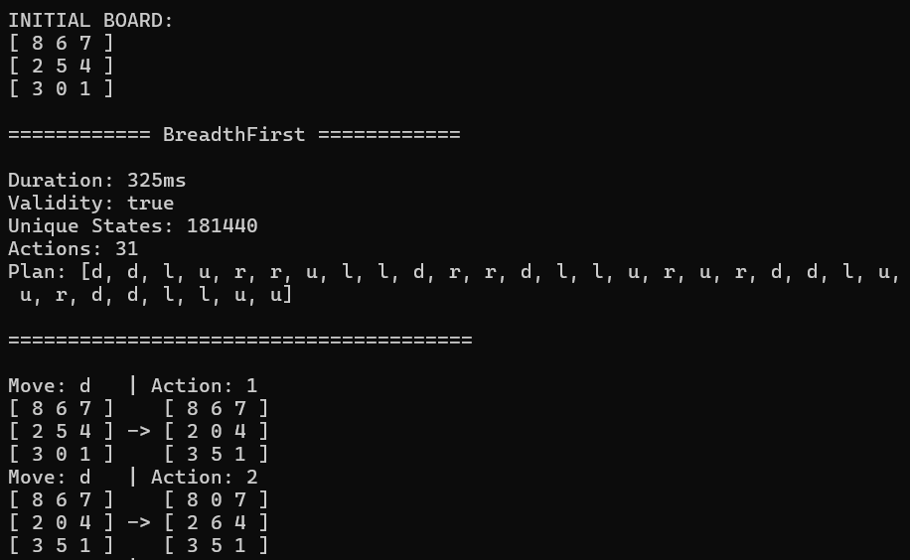



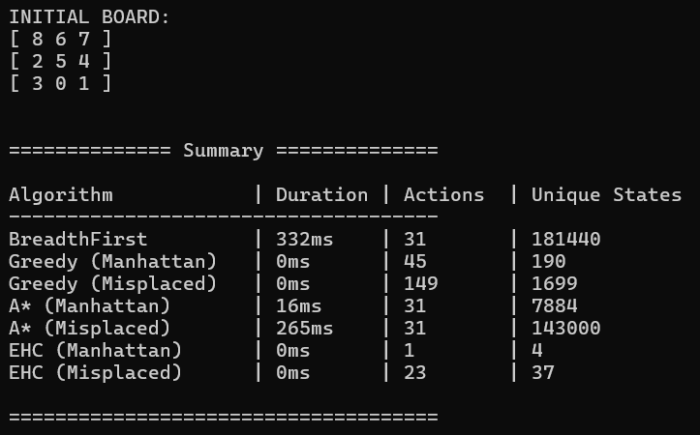 **. . .**

**Evaluation**

[1] State Space is 9!/2 as inverted boards cannot be accessed.   
[2] A state is at most 31 moves away from an initial state.

//Breadth evaluation.  
This search algorithm ensures the shortest path to the goal state by exploring all states layer by layer. However this exhaustive search has a significant drawback in that it generates all states up to the goal state’s depth. Since all states are at most 31 moves away, the entire state space is generated as seen when testing with initial test states 1 and 2 which are 31 moves away from their goal.  
Furthermore if a goal state is at layer $n$ and layer $n+1$ exists, layer $n+1$ will be partially explored. The percentage of layer $n+1$ to be generated grows as distance m grows. ( $m$ being the distance from the initial state of a layer).  
This makes the BFS impractical for problems with deeper state spaces or higher branching factors.

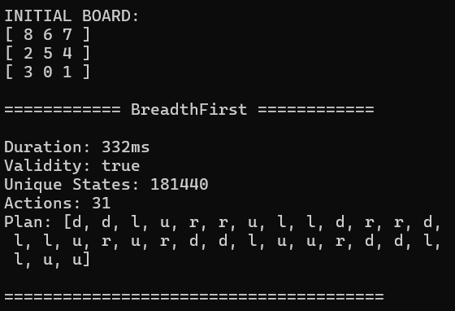 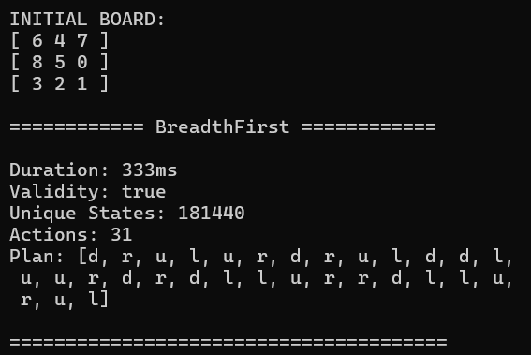

//Greedy evaluation.  
This search algorithm yields very fast search times while. However, GBFS exhibits a form of 'tunnel vision,' focusing solely on heuristic costs and ignoring the actual cost from the start state to a given node, unlike A*. As a result, it does not guarantee the shortest possible plan, as it does not consider the full cost of reaching the goal.  
This makes GBFS very good at getting to a goal node quickly and when the Manhattan distance function was used was also able to keep unique states generated low but doesn’t ensure the optimal plan. – Discrepancy between Manhattan and misplaced.

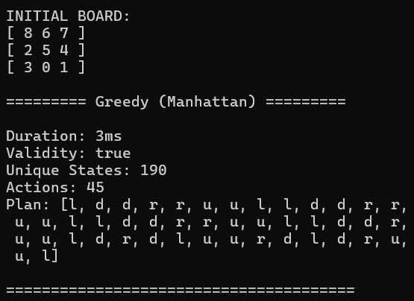 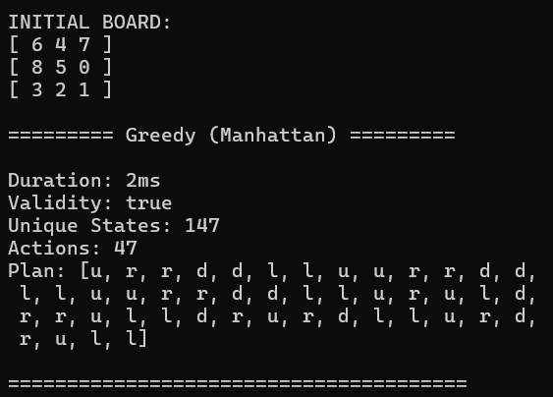

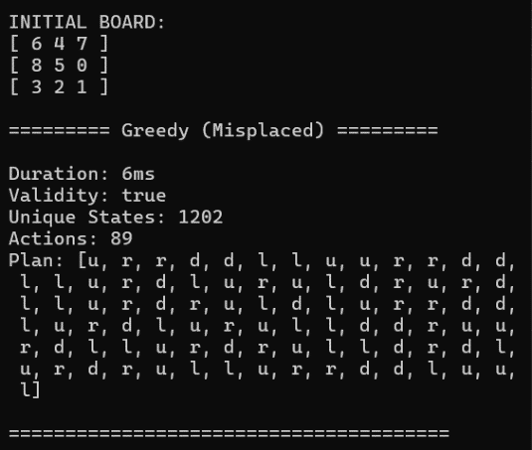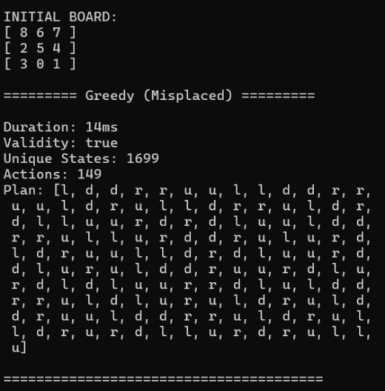

//A evaluation

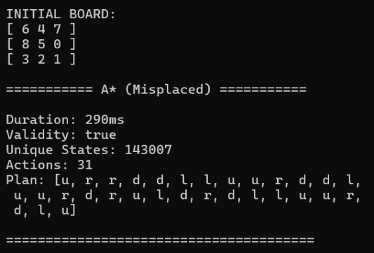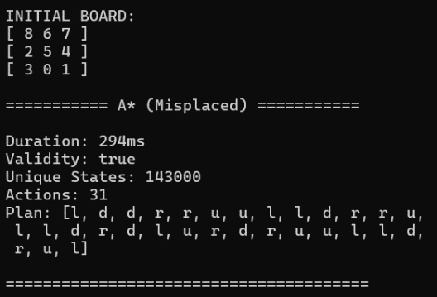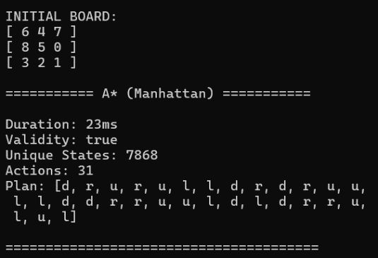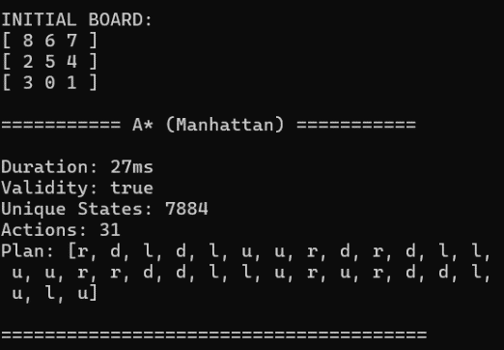

//EHC evaluation

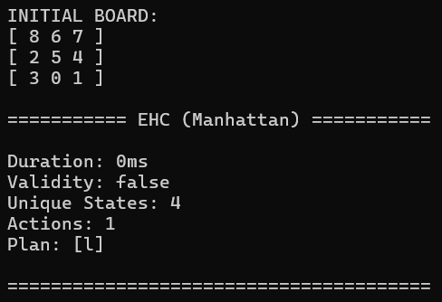 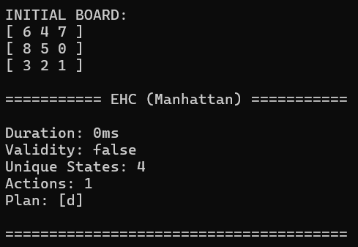

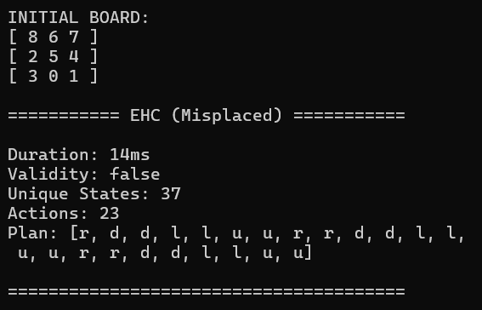 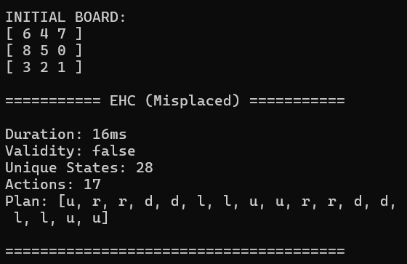

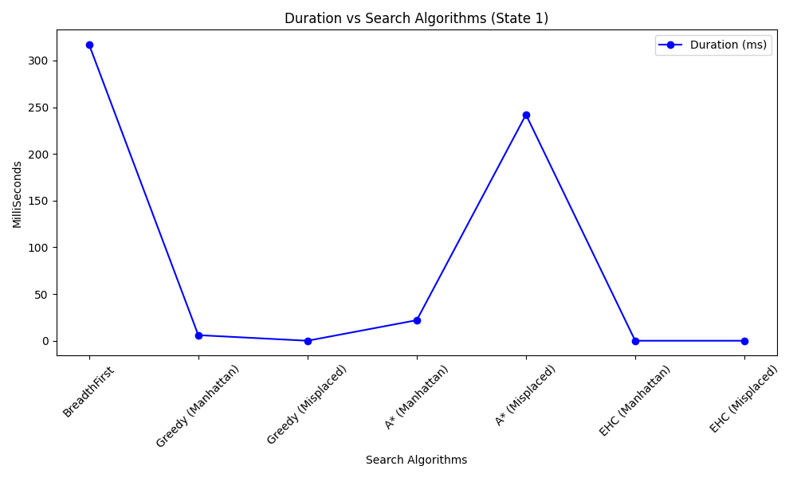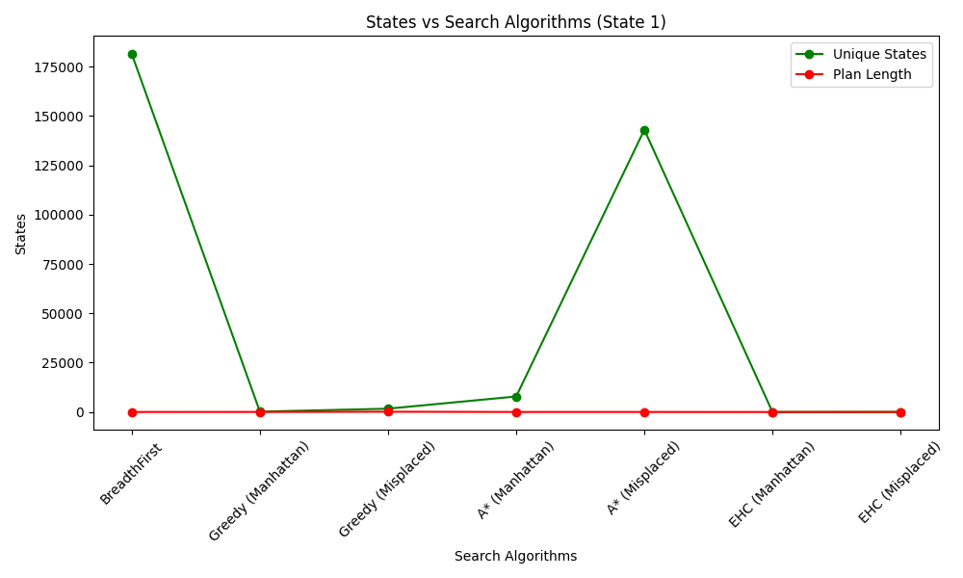

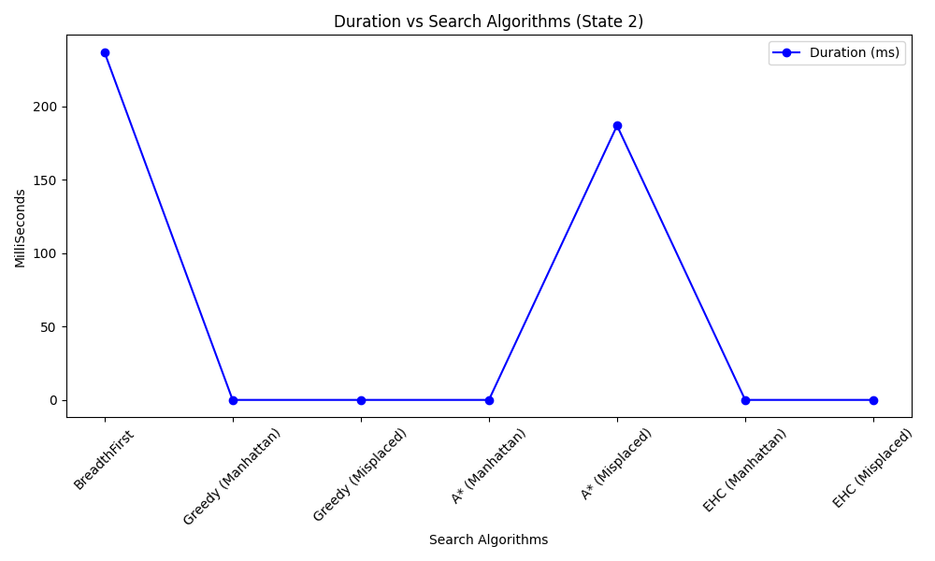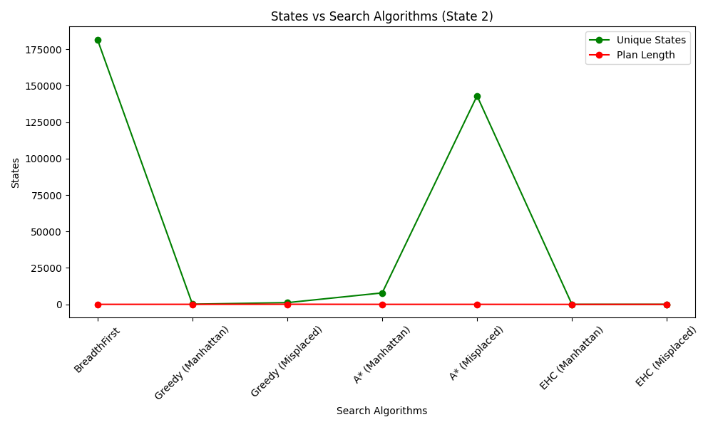

**Part 2: PDDL Implementation**

PDDL provides the ability of separating a planning problem into a planning domain and problem instances. This is great for representing planning problems due to generalization of a solution plan and also for easy problem instance creation. PDDL supports STRIPS (Stanford Research Institute Problem Solver) which provides a number of useful components to plan out a solution. These include:

* Predicates – facts which describe the environment of the space.
* Actions -
  + Preconditions – some actions have certain requirements to execute.
  + Add/delete effects – changing of facts when going through an action.
* Initial state - set of facts which hold for the beginning of the planning process.
* Goal state – provides the facts required to reach final state.

PDDL is useful especially in our case since our scenario is fully deterministic, meaning all tiles and positions on the grid are visible. For our project, we must present a domain about a 3 by 3 grid with numbers from 1 to 8 randomly allocated and 1 empty position.

Domain file: Automated.pddl

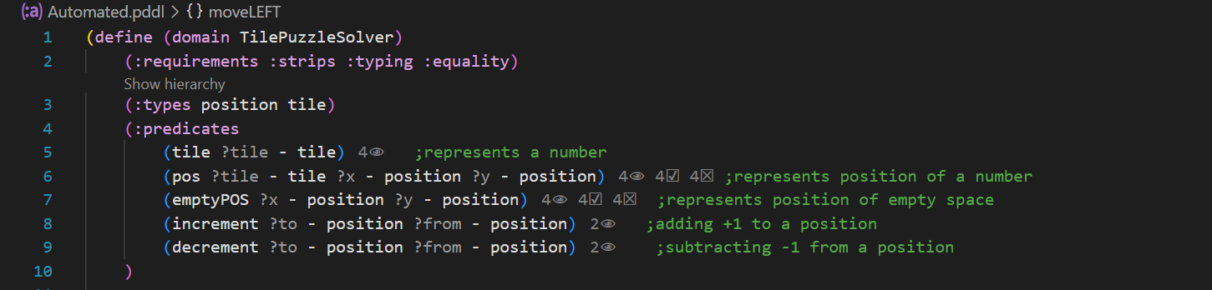

The above represents the fundamentals aspects of the domain file;

* Requirements:
  + strips to define actions and preconditions
  + typing to introduce object types
  + equality for logical comparing
* Types:
  + Tile – represents a puzzle tile of the grid
  + Position – represents the coordinates on the grid of a specific tile or empty space.
* Predicates:
  + Tile – validates a tile variable
  + Pos – describes the coordinates of a tile
  + emptyPos - describes the current position of where there is no tile (empty space/ 0)
  + increment – to represent a +1 addition to a previous position
  + decrement – to represent a -1 subtraction to a previous position

After gathering the fundamentals of the domain, then we create the possible actions. Each action will have its own unique requirements(preconditions) and own effects.

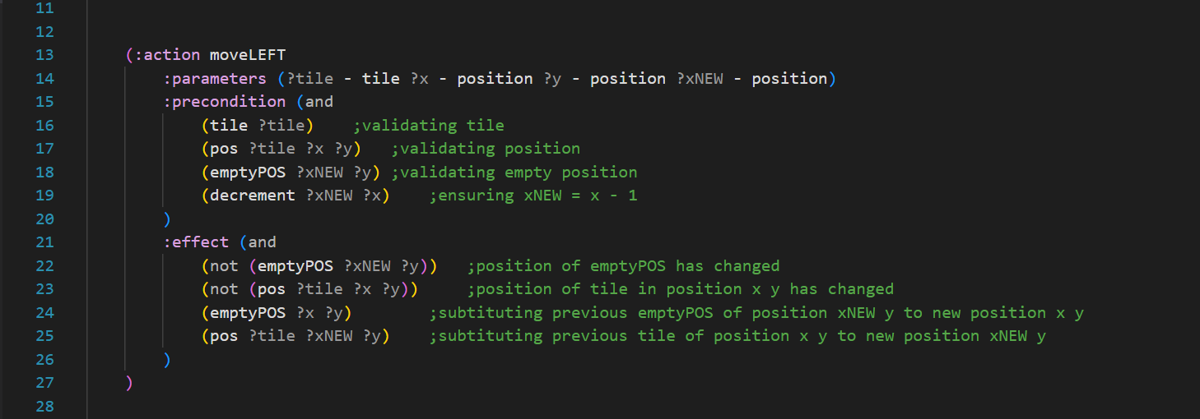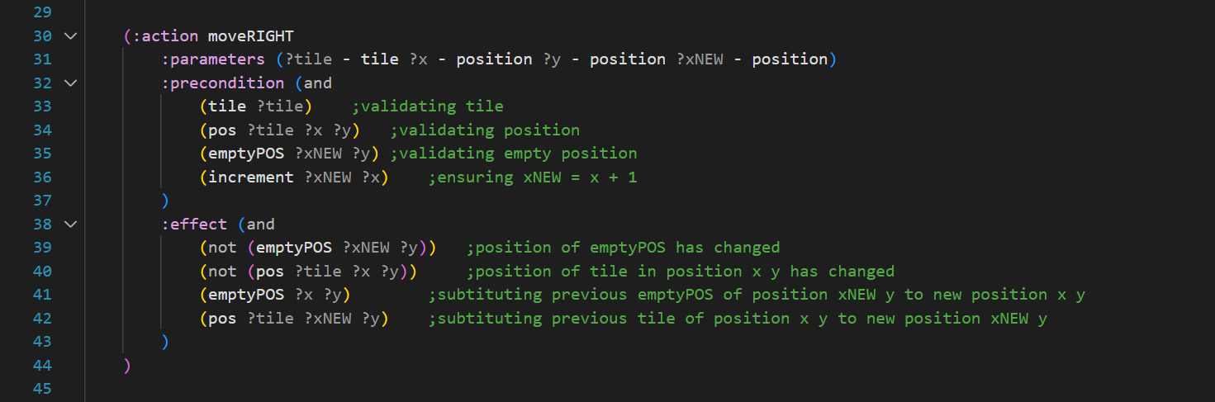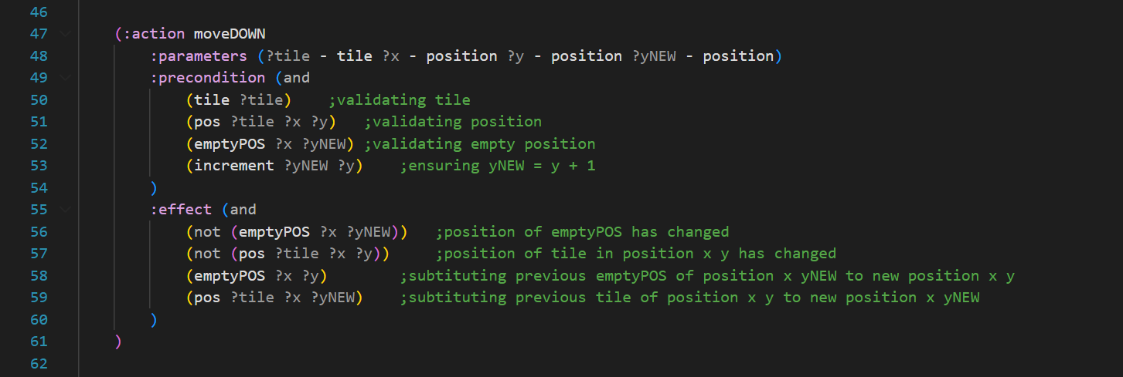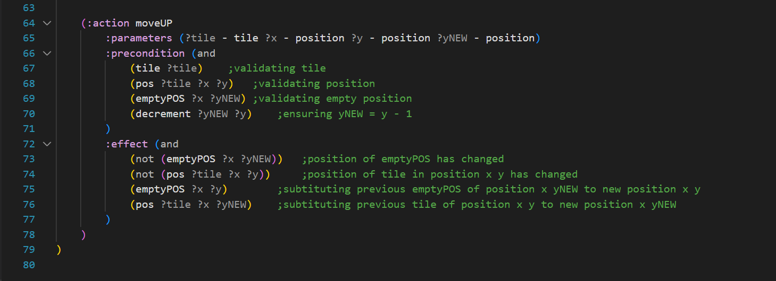

Actions:

* moveLEFT:
  + preconditions – checks and validates all called parameters and ensures a decrement between variables.
  + effects – states that the previous positions are no longer valid and swaps the empty position with the tile in position x y.
* moveRIGHT:
  + preconditions – checks and validates all called parameters and ensures an increment between variables.
  + effects – states that the previous positions are no longer valid and swaps the empty position with the tile in position x y.
* moveUP:
  + preconditions – checks and validates all called parameters and ensures a decrement between variables.
  + effects – states that the previous positions are no longer valid and swaps the empty position with the tile in position x y.
* moveDOWN:
  + preconditions – checks and validates all called parameters and ensures an increment between variables.
  + effects – states that the previous positions are no longer valid and swaps the empty position with the tile in position x y.

Problem Definitions:

Our program ranges 6 different problem, 1-4 are solved within 2 to 3 moves while 5 and 6 are longer and have deeper state searching to solve.

Our problems are defined as following:

* object creation – initializing variables and setting their object type.
* Init – sets all puzzle tiles from t1 to t8, sets possible increments and decrements (1->2->3) and (3->2->1). Then the initial state of the puzzle board is created. Usually this is the only part of the file which differs from one problem file to another, since the object type declaration, variable creation, and goal state are kept the same.
* Goal – represents the state of facts which must be true for the algorithm to stop (Final state). The goal state is the same for every PDDL problem;

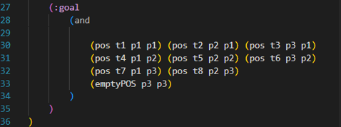

Problem 1: problem1.pddl

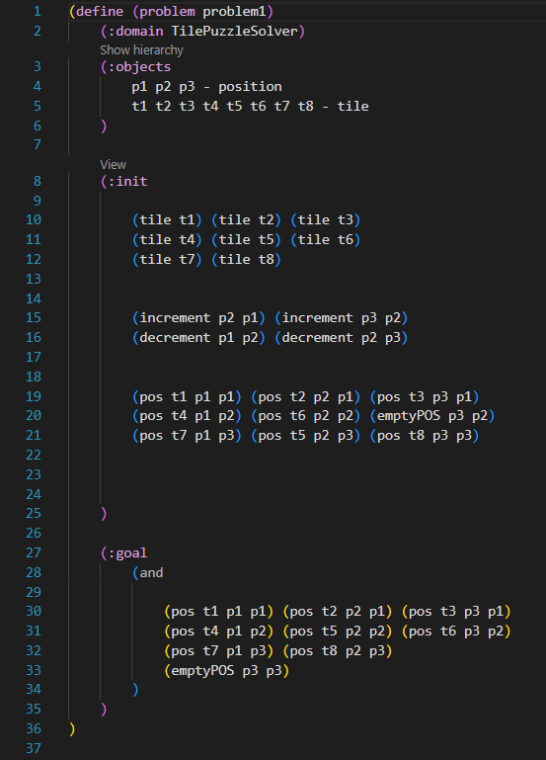

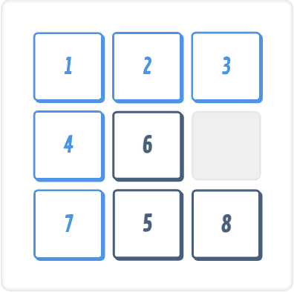

Initial state of problem 1:

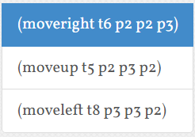

Solution of problem 1:

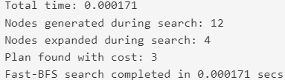

Plan length: 3

States expanded: 4

States discovered: 12

Time taken: 0.000171

Problem 2: problem2.pddl

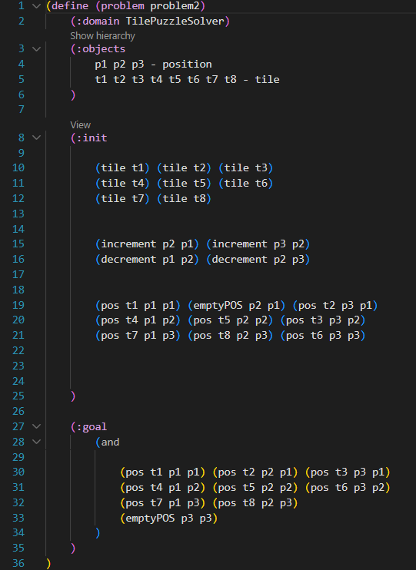

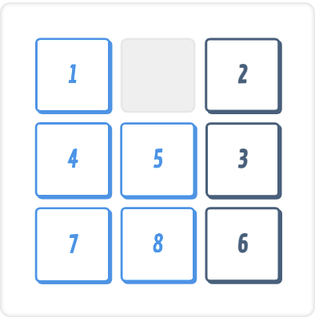

Initial state of problem 2:

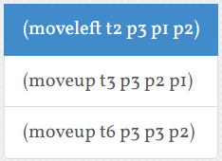Solution for problem 2:

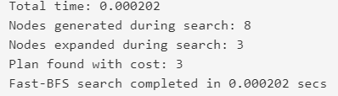

Plan length: 3

States expanded: 3

States discovered: 8

Time taken: 0.000202

Problem 3: problem3.pddl

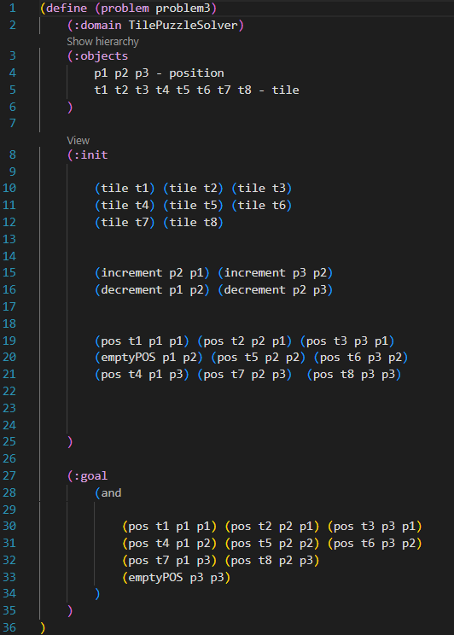

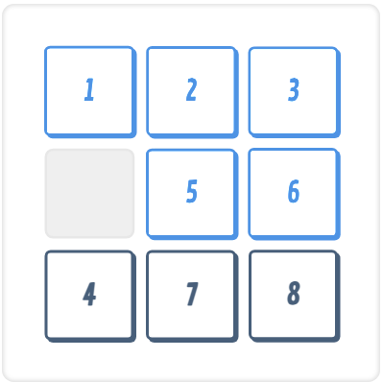

Initial state of problem 3:

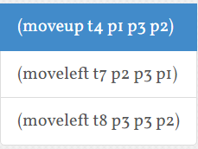

Solution for problem 3:

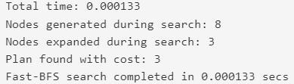

Plan length: 3

States expanded: 3

States discovered: 8

Time taken: 0.000133

Problem 4: problem4.pddl

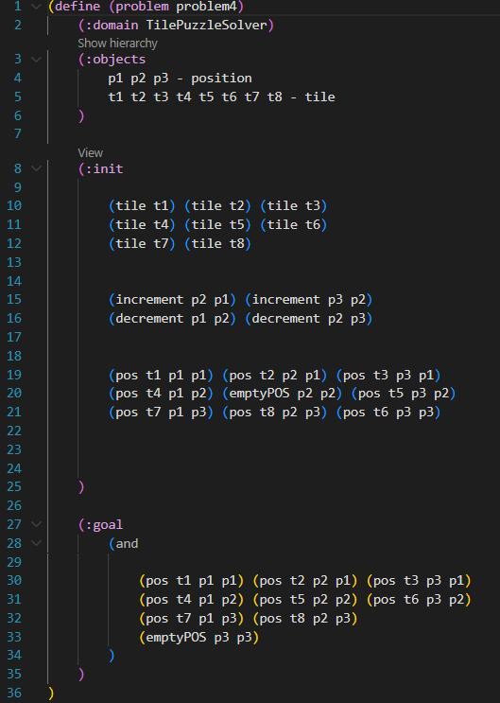

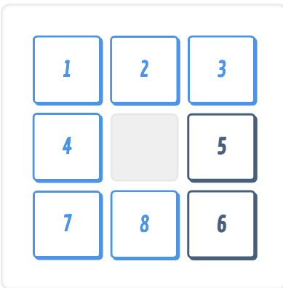Initial state for problem 4:

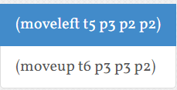Solution for problem 4:

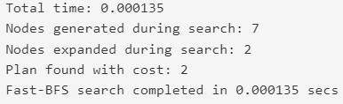

Plan length: 2

States expanded: 2

States discovered: 7

Time taken: 0.000135

Problem 5: problem5-hard.pddl

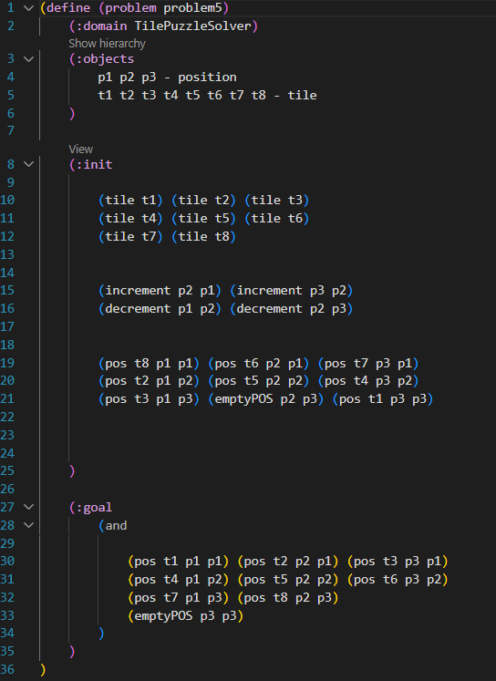

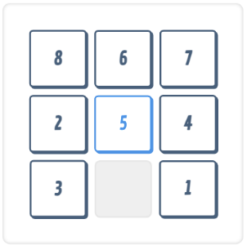Initial state for problem 5:

Solution for problem 5:

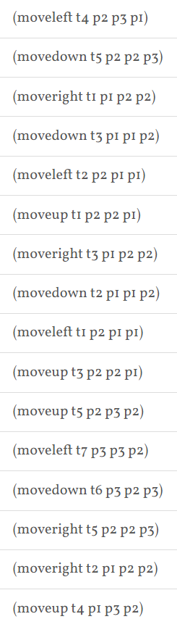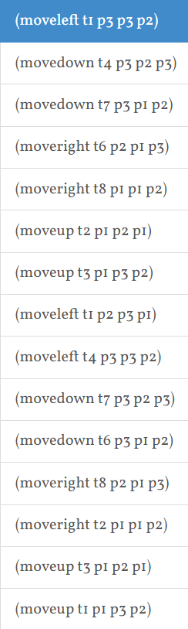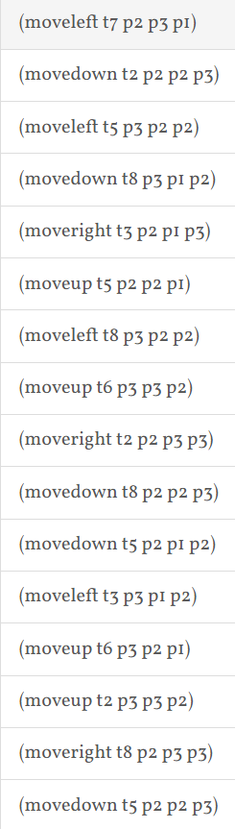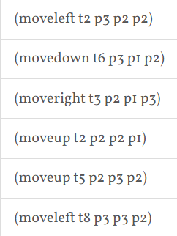

Plan length: 53

States expanded: 1261

States discovered: 3413

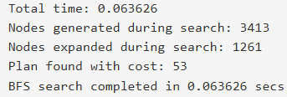Time taken: 0.063626

Problem 6: problem6-hard.pddl

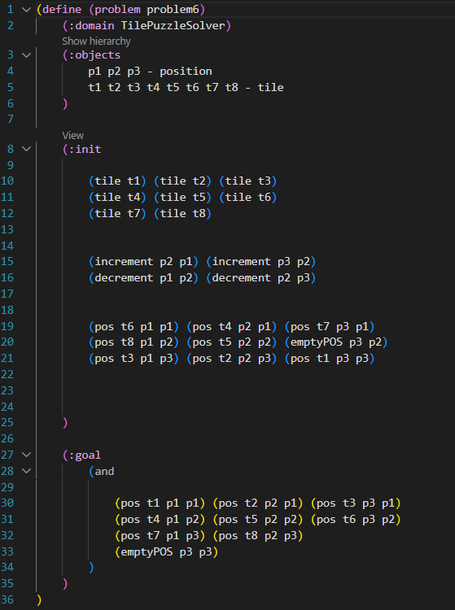

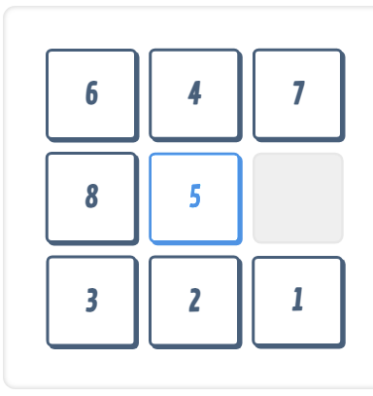Initial state for problem 6:

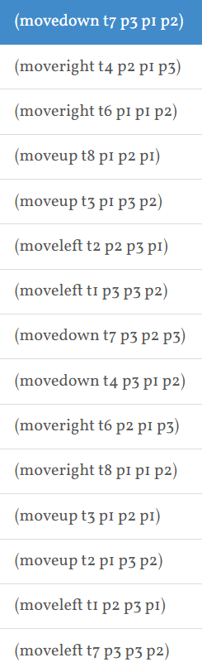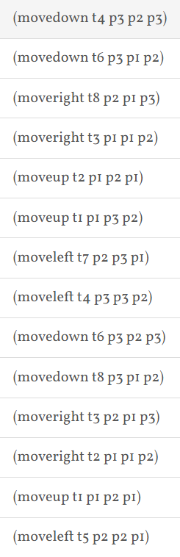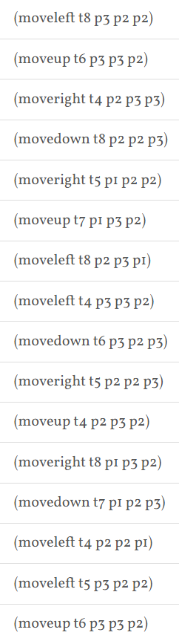

Solution for problem 6:

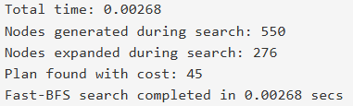

Plan length: 45

States expanded: 276

States discovered: 550

Time taken: 0.00268

Comparing results of Part 1 and Part 2:

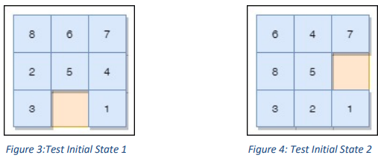

References:

Distribution of Work: